Exchequer v5.70

Rebranding Notes

Version 1.0

Splash Screen
Please note that we overlay controls over this bitmap at runtime as shown on the right:-

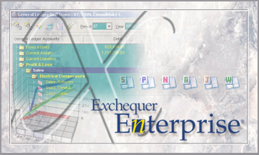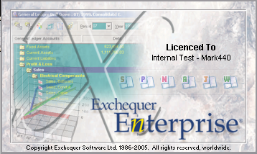
357x214pixels in 16 million, 256 And 16 colours

Multi-Company Manager
The following bitmap is used within the MCM for logins, please note that we overlay controls over the bitmap at runtime as shown on the right:-
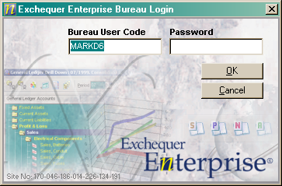
357x214 pixels in 16 million, 256 and 16 colours.
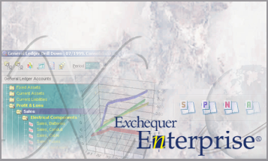

OLE Server
The OLE Server main form currently uses a cut-down version of the tall setup bitmap and the OLE Server login re-uses the MCM Login bitmap:-
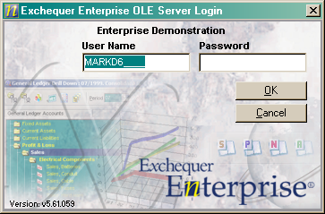
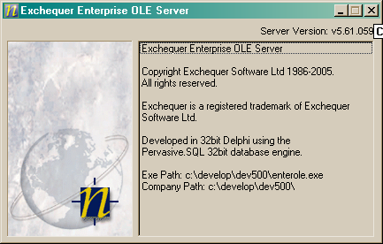

The help about dialogs for the Data Query and Drill-Down Add-Ins re-use the Enterprise icon:-
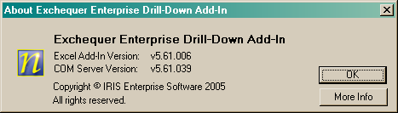

Form Designer
The Form Designer has the following toolbars, the first shares a lot of the bitmaps with the Visual Report Writer and the second is common to all print preview windows throughout the system:-

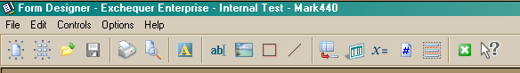

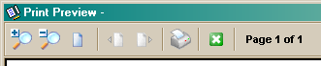

Toolbar bitmaps are 22x2 in 16 million colours and because they are transparent anti-aliasing needs to be done very carefully (remember all the problems with the VRW Formula buttons!). They also come in three variants for disabled, enabled and focussed.

The Form Designer Toolbar bitmaps are also mirrored in the menus:-

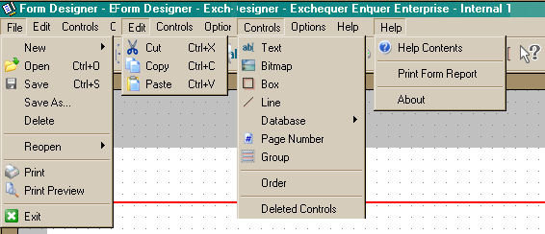

The menu bitmaps are 16x16 pixels in 16 million colours.

Exchequer Install CD Auto-Run
The CD auto-run program on the Exchequer CD runs up (below-right) and presents the user with the list of options, the options are added within the code, the original bitmaps is shown below left:-

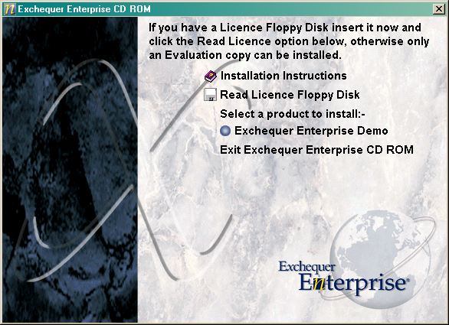

580 x 400 pixels in 256 colours.

Also we have three icons against the options which may need updating, the first is a ling into the help, the second is a file open dialog for reading the licence and the third (the blue ball) is shown against any installs the user can run. I noticed that the blue ball looked quite like the IRIS icon and so probably needs changing. These help and disk icons are 17x17 pixels in 16 million colours and the blue ball icon is 14x14 in 256 colours.

Setup Program
The look and feel of the setup needs consideration as well, this is a fairly standard window:-

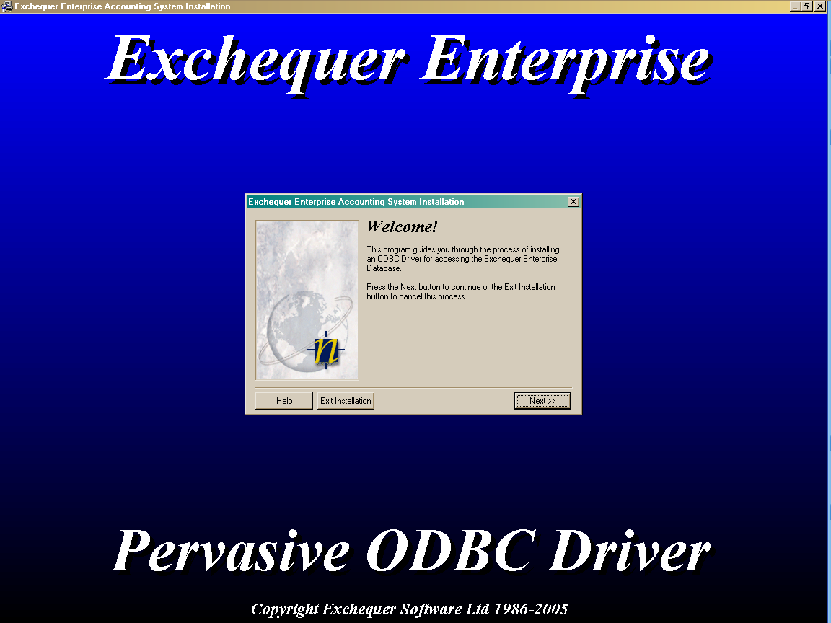
Times New Roman 40pt Bold Italic
Times New Roman 36pt Bold Italic
Times New Roman 10pt Bold Italic
MS Sans Serif 8pt
Times New Roman 18pt Bold Italic

Setup & Miscellaneous Utility dialogs
This bitmap is 143x1995 pixels in size and in 256 colours, and is used in almost every part of the setup and the varions maintenance utilities within Exchequer. It is so tall because it is used on windows of varying sizes and the bottom x pixels are used depending on the window size.



